**Analysis Topic 10**

**System Analysis & Design & CIS-2245**

|  |  |
| --- | --- |
| Author: | Christopher Sigouin |
| Date: | November 21, 2015 |
| Due Date: | November 23, 2015 |
| Assignment: | Analysis Topic 10 |
|  |  |
|  |  |
| Mark: | __________ |

Questions for your respective case study are:

* Based on the information provided create a Storyboard interface design for your system.  It should include at your 'MAIN' interface and 3 other key interfaces of your system.
* Consider security/access controls in your interface design.
* Your design should be created in either Visio (interface design) or .NET IDE.

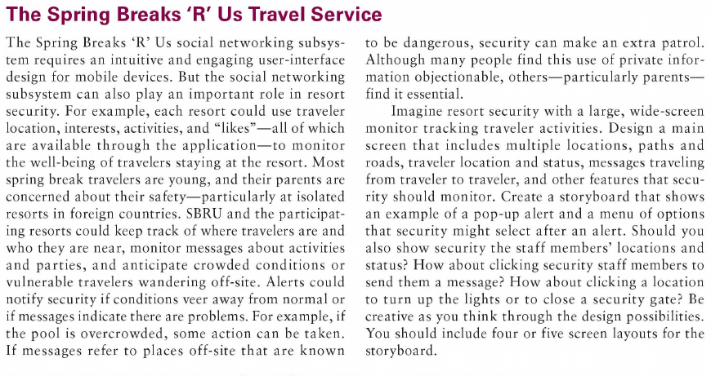

Below are the interface drawings for the following:

* Main Interface
* Lights & Locks
* Manage Tracking
* Resort Personnel Directory



The main interface of the security system displays all vital links and controls overall. Each section has a dedicated genre (Student, Resort and Location) as well as applicable buttons to that genre. On the left, a sidebar holds an alert screen for any vital messages that someone utilizing the system should see. The lower portion is a control panel with highly used functionality for daily tasks.

Each button within its section can be used to either open the screen within the same window (by clicking on the larger portion) or displaying the item within its own window (clicking on the bottom right corner of each button). This will allow the user to dedicate windows for multi-tasking purposes.

Buttons that are highlighted in RED are the interface views created within this document.



The functionality for Lights & Locks is fairly self-explanatory. The similar right side bar is shows as in the main interface. The left side has a quick search box and large listing of locations that would be controllable remotely for lights or locks. As there may be cameras in that area, a feed would be available to view the situation. Below the feed would be controls to manage the lightning and lock systems. Below those controls would be information on the current status of these systems.

A button on the bottom left corner would take the user back to the main interface screen.



The ‘Manage Tracking’ interface is dedicated to a special scenario where a particular student would be ‘tracked ‘due to possible issues with said student. These would include any prior issues or logged incidents that could have occurred. As previously, the same right side bar for alerts and main control panel functionality is shown. Items denoted with ‘ << EDIT >> ‘ can be changed by the user of the system.



A directory specifically for resort personnel is shown here. A user of the system would be able to quickly search for an employee here and connect with them. Some details regarding further contact information, last known location and any relevant statuses would be shown here.